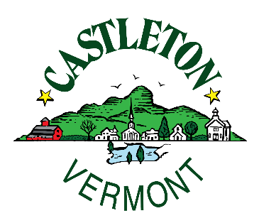
PUBLIC NOTICE
POSTED 06-16-22

DUE TO STAFFING ISSUES
THE TRANSFER STATION WILL BE CLOSING AT 4:00PM ON TUESDAY JUNE 28TH & THURSDAY JUNE 30TH
PLEASE PLAN AHEAD.

